Editorial

Chennai Connexions has been a great tool that connects all our local members. Each issue covers issues and update from the industry experts.

This issue talks about some of the important updates that would affect most of us. We welcome you to contribute articles to the newsletter and share your knowledge and expertise with all the other members.

We hope you find this edition useful. Happy reading!

Do you have an article for the next edition of Chennai Connexions? Please send it to secretary@aahamchennai.org!

**Insights in this edition**

**Post Pandemic & Medicaid Redetermination --------------------------------------------------Pg. 2**

**Important of Payment Posting Reconciliation -------------------------------------------------Pg. 4**

**Medicare Program Discarded Drugs and Biologicals ------------------------------------------Pg. 6**

**AI’s Transformative Impact on Medical Billing and RCM--------------------------------------Pg. 8**

**Health Insurance Portability and Accountability Act------------------------------------------Pg.10**

**Post Pandemic & Medicaid Redetermination**

Covid-19 impacted millions of lives and families bringing many government bodies to a grinding halt. However, as the pandemic receded and as we start picking up the threads and look ahead, it is time to revisit one of the most populous US government programs Medicaid. One of the lifeline programs covering about 90 million people in the United States, any break in coverage impacts the health of the neediest and has a cascading effect on the community in general.

When the pandemic started, thanks to the proactiveness of the government in understanding how health insurance is paramount for all, especially people below poverty level, the Families First Coronavirus Response Act (FFCRA) brought in by the Congress, ensured continuous enrollment provision that many people maintained their Medicaid coverage and successfully endured multiple deadly waves.

However, with the end of PHE, larger percentage of them started losing their coverage. A research reveals about 8 to 25 million people will lose their coverage. CMS pegged the number at 15 million. The saving grace is not all of them will become uninsured as they opt for other coverages.

Since the program is largely administered by the States, there are inconsistencies in the period they started dis-enrolling. While some started in May 2023, others did not start dis-enrolling until July 2023. The disenrollment rates and percentage vary across states and clear visibility on the same is yet to unfurl.

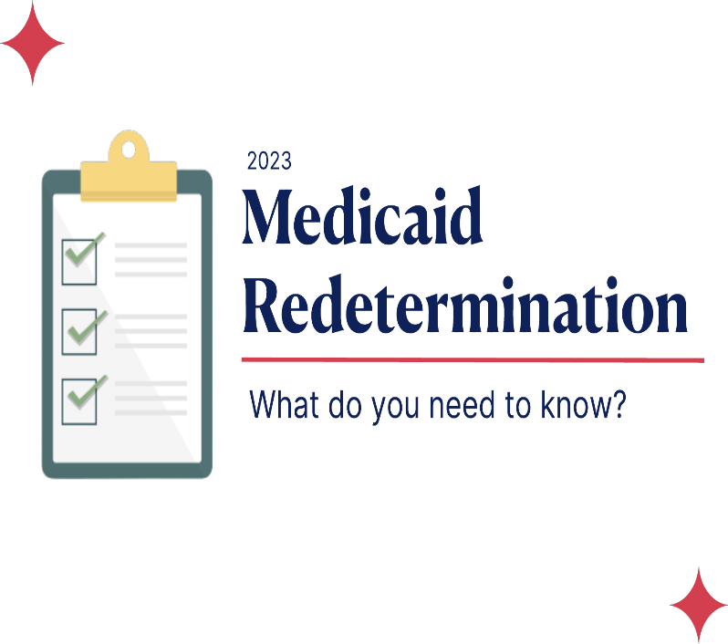

However, thanks to the Consolidated Appropriations Act, all states are required by law to report updated data continuously for CMS to make it visible to all. Penalties stare at states that do not comply. With such a huge population’s coverage at stake awareness on the renewal process poses a challenge and communication at the grass root level holds the key.

The ripple effect of Medicaid redetermination impacts physicians, hospitals and their associated businesses including billing companies. Hence, it has become more important than ever to check eligibility of Medicaid Recipients, to ensure they have continuous coverage and proactively avoid any fallouts. A challenging yet doable task awaits the industry.

**Muthukumar Padmanabhan CRCP**



**Importance of Payment Posting Reconciliation**

Payment posting refers to the viewing of the payments and the financial picture of medical practice. Getting an overview of the financials is essential in determining revenue leaks and solve it immediately.

Receiving checks from your payers doesn't mean that everything is fine. You should still evaluate your payment posting process on a periodic basis. Here are some tips for a careful review.

A well-done payment posting process can help you identify opportunities to increase revenue by watching for daily trends within your practice. Because payment posting has such high potential to increase profits and smooth out the overall medical billing process.

Daily payment collection reconciliation would help to address any issue in collection. Always having monthly/daily collection trends is more important to identify any small drop. Reconciliation staffs should know about all insurance payment method and payment interval (Daily/Weekly). Any down in expected payment, immediate communication needs for further review.

Ensure to reconcile the ERA/EOBs to avoid payment missing.

Handling denials - report and reroute denied claims to the appropriate coding and denial management team for rework and re-submission to payers in a timely manner.



Patient responsibility - identify and move balances to the patient's responsibility helps to ensure faster patient billing.

Write-offs and adjustments - process write-offs and adjustment and report any unusual contractual adjustments while processing payment.

TAT is more important. If you don’t post the payment quickly, your billing system may automatically send a statement, even though the patient already paid. You'll either create a refund (if the patient pays again) or receive an angry call from a patient -- either way, it costs you money and tarnishes your level of service a bit.

Watch your paper check payers and Credit card payers to work with those insurance to convert to EFT for faster collection. And always watch the paper EOB payers to convert into ERA to avoid manual posting time and increase in posting quality.

**Prakash Velsamy CRCP**

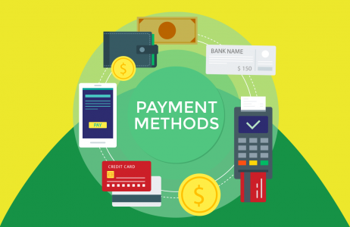

**Medicare Program Discarded Drugs and Biologicals – JW Modifier and JZ Modifier Policy**

Effective January 1, 2017, providers and suppliers are required to report the JW modifier on all claims that bill for drugs and biologicals separately payable under Medicare Part B with unused and discarded amounts from single-dose containers or single use packages. Also, providers and suppliers must document the number of discarded drugs in Medicare beneficiaries’ medical records.

Effective July 1, 2023, providers and suppliers are required to report the JZ modifier on all claims that bill for drugs from single-dose containers that are separately payable under Medicare Part B when there are no discarded amounts. CMS encourages physicians, hospitals and other providers and suppliers to care for and administer drugs and biologicals to patients in such a way that they can use drugs or biologicals most efficiently, in a clinically appropriate manner.

To align with the JW modifier policy, the JZ modifier is required when there are no discarded amounts of a single-dose container drug for

which the JW modifier would be required if there were discarded amounts.



Q1. What is the JW modifier?

The JW modifier is a Healthcare Common Procedure Coding System (HCPCS) Level II modifier required to be reported on a claim to report the amount of drug that is discarded and eligible for payment under the discarded drug policy. The modifier should be used only for claims that bill single-dose container drugs.

Q2. What is the JZ modifier?

The JZ modifier is a HCPCS Level II modifier reported on a claim to attest that no amount of drug was discarded. The modifier should only be used for claims that bill for single-dose container drugs.

The JW and JZ modifiers do not apply to drugs administered in a Rural Health Clinic (RHC) or a Federally Qualified Health Center (FQHC), as their payment is included in the RHC’s all-inclusive rate or the FQHC’s prospective payment system rate for the patient’s visit.

**Abdul Latheef CRCP**



**Source:** (MLN Matters Number: MM13056)

**AI’s Transformative Impact on Medical Billing and RCM**

Artificial Intelligence (AI) is transforming medical billing by improving efficiency, reducing errors, and reducing costs. Artificial Intelligence (AI) is transforming medical billing in several ways, including:

1 **Automated Coding:** AI-powered software can analyze medical records and automatically assign appropriate billing codes, reducing errors and increasing efficiency. This can save time for billing professionals and reduce the risk of denied claims.

2 **Claims Processing:** AI can automate the process of claims processing, including verification of patient eligibility, checking for errors, and submitting claims to insurance providers. This can improve accuracy, reduce the likelihood of denied claims, and speed up the reimbursement process.

3 **Fraud Detection:** AI can analyze large amounts of billing data to detect patterns  
of fraud, waste, and abuse. This can help prevent fraudulent claims and save healthcare providers and insurance companies billions of dollars each year.

4 **Payment Optimization**: AI algorithms can analyze payment data to identify patterns and predict payment trends. This can help healthcare providers optimize payment schedules and improve cash flow.

5 **Revenue Cycle Management**: AI can automate the revenue cycle management process, including patient registration, claims processing, and payment collection. This can improve efficiency, reduce errors, and speed up the payment process.



AI can also be used for medical billing denial management to reduce the risk of denied claims and increase revenue. Here are some ways in which AI can be used for medical billing denial management:

1 **Predictive Analytics:** AI algorithms can analyze medical billing data to identify patterns and predict the likelihood of claims being denied. This can help healthcare providers proactively address issues and reduce the risk of denied claims.

2 **Automated Appeals:** AI-powered software can automatically generate appeals for denied claims based on specific denial codes. This can save time for billing professionals and increase the likelihood of successful appeals.

3 **Real-time Monitoring:** AI can monitor claims in real-time and flag potential issues before they result in denied claims. This can help healthcare providers identify and address issues before they become major problems.

4 **Root Cause Analysis:** AI can analyze denied claims data to identify common causes of denials, such as coding errors or missing documentation. This can help healthcare providers to address these issues and reduce the risk of future denials.

5 **Performance Metrics:** AI can provide performance metrics to help healthcare

**Vijila P V CRCP**

providers’ monitor their denial management process and identify areas for improvement. This can help providers optimize their processes and reduce the risk of denied claims.



Overall, AI has the potential to transform medical billing by improving accuracy, efficiency, and reducing costs. As AI technology continues to advance, we can expect to see even more innovative applications of AI in medical billing in the future.

Source: <https://doccharge.com/blog/5-ways-artificial-intelligence-is-transforming-medical-billing/>

**Health Insurance Portability and Accountability Act**

The Health Insurance Portability and Accountability Act (HIPAA) of 1996 is a set of regulatory standards that intend to protect private and sensitive patient data from hospitals, insurance companies, and healthcare providers. HIPAA compliance is regulated by the Department of Health and Human Services (HHS) and the provisions of the Act are enforced by the Office for Civil Rights (OCR).

The OCR investigates HIPAA violations that compromise the integrity of PHI and levies appropriate fines based on a tiered structure with corresponding caps. Criminal charges may be applicable for some incidents.

Consider these recent HIPAA Enforcements

* A dental practice in North Carolina was fined $50,000 after a patient left a poor Google review anonymously and the practice, in its response, revealed the patient’s full name.
* [Lifespan Health System](https://public3.pagefreezer.com/content/HHS.gov/31-12-2020T08:51/https:/www.hhs.gov/about/news/2020/07/27/lifespan-pays-1040000-ocr-settle-unencrypted-stolen-laptop-breach.html) was required to pay $1,040,000 for a breach of electronic PHI (ePHI) after the theft of an unencrypted laptop that affected 20,431 people.

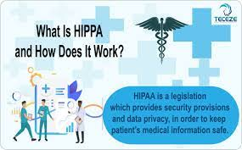

* **Being aware of fines and penalties**
* OCR prefers to resolve HIPAA violations through non-punitive methods like voluntary compliance or offering technical guidance to assist covered entities with non-compliant areas. However, if the violation is severe or has been allowed to linger for long, tier-based financial penalties are imposed:
* **Tier 1 –** A violation that the covered entity was not aware of and could not have realistically prevented. Reasonable care was taken to conform to HIPAA Rules. Fines of $100 – $50,000 per incident
* **Tier 2** – A violation that the covered entity should have been aware of, but which could not be prevented even with a reasonable amount of care. Fines of $1,000 – $50,000 per incident
* **Tier 3** – A violation that occurred due to willful neglect of HIPAA Rules, in instances where attempts were made to correct it. Fines of $10,000 – $50,000 per incident
* **Tier 4** – A violation that occurred due to willful neglect, wherein no effort has been made to correct it. Fines of $50,000 and above.

**Stay updated with HIPAA changes!**

HIPAA compliance is an ongoing process, so you need to stay up to date with the latest developments. The recent additions to HIPAA are:

* Allowing patients to examine their PHI in person and take notes or photographs.
* Decreasing the maximum time for providing access to PHI from 30 days to 15 days
* Required entities must publish their fee schedule for PHI access and disclosure on their websites.
* Enlarging the definition of healthcare operations to encompass care coordination and case management.

**7 Important Points That Form an Effective HIPAA Compliance Program**

The HHS Office of Inspector General (OIG) established the Seven Elements of an Effective Compliance Program, which is intended to help companies evaluate compliance solutions or build their own compliance programs.

In addition to meeting HIPAA Privacy Rule and Security Rule standards, an effective compliance program should be able to handle these seven elements:

* Implementing written policies and procedures with respect to a code of conduct/ethics, corporate compliance program, disaster recovery plan, and training, acknowledgment, and corrective action plans
* Assigning a Compliance officer and setting up a compliance committee
* Imparting effective education and HIPAA training
* Building open lines of communication
* Performing internal auditing and monitoring to check for relevance.
* Enforcing through well-publicized disciplinary guidelines
* Reacting promptly to violations and executive corrective action plans

During OCR investigations of HIPAA violations, federal HIPAA auditors will compare the company’s compliance program against these seven elements.

**Dulkarine Sikkandar CRCP**

